**Increase Network Up Time, Load Balance and Efficient routing Model for heterogeneous Wireless Sensor Networks**

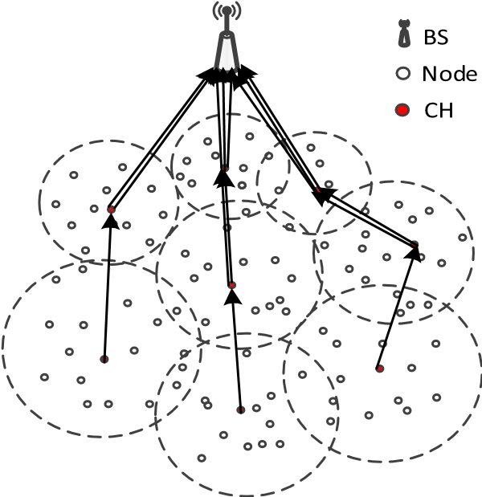

**Issues:**

* “Cluster Head (CH) closer to the base station (BS) tends to die very fast in comparison with far away nodes due to inter-cluster communication”,
* within the Cluster the Cluster Head tends to die very fast in comparison other nodes because it must act as collection centre to collect date from all the node and forward to Base Station (some time it uses other CH as relay to forward to BS)

**Solution:**

**CH Selection:** To avoid these issues, we propose model where each nod has capacity to act as CH. CH is selected based on power availability at Node on regular intervals.

This avoids Burdon on single node, Burdon is shared by each node in a cluster at different intervals and will achieve load balancing. This module will be very reliable because if any CH go’s down due unavoidable circumstances other node will take the position as CH in next interval. Because of this all the node in a cluster will get active.

Simulation Considerations:

* There are **two types** of nodes (some are with more power, some with less power)
* Cluster formation based on distance from BS, physical location,
* CH is selected with in the cluster based on its **RANK (based on energy condition**), it will be dynamic, current CH for a given cluster will lose CH position as it loses energy during operation, new node with in the cluster will take position as CH
* Simulation done on **slots**,
* sensers send the information to CH at each slot,
* CH will **aggregate collected** information from Sensers and transmit to BS via selected path.
* **Path** is determined **dynamically** based on availability of the intermediate CH, their distance and energy condition.
* **Life time of each node is recorded**.
* **Total Network UP time recorded**.
* Energy auditing is based on:
  + 1Unit for sensing and transmit to CH
  + 2Unit for aggregate and send to BS.
  + 1Unit for forwarding received aggregated data by Intermediate CH to BS

**Project implementation done in Java.**